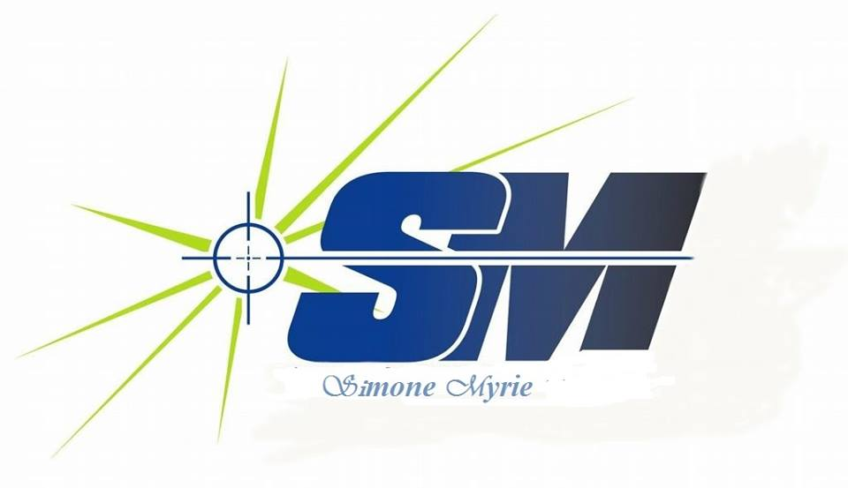

Self-Publishing Tips

F
or those of you who are still skeptical about the extent of self-publishing’s promise, here is all the inspiration you need. With book deal, things are only looking up for this indie giant. Here she shares her top tips for self-publishing.

When you’re first starting out as an author, it can be incredibly daunting. I remember the feeling well. Back when I started self-publishing in 2012, there really wasn’t much information out there on how to market your books and be successful at it. I had to find my own way, and along the way I learnt a lot. Since then, I’ve gone on to sell more than half a million books, with my latest becoming the biggest selling self-published book of the year and landing me a huge publishing deal. That took five years of working out what works and what doesn’t. Separating the wheat from the chaff is difficult, especially with so many people professing to be self-publishing experts. Even today, there’s a lot of rubbish out there in the industry. People with barely a few hundred sales put themselves up as gurus to tell others what works and what doesn’t. The signal to noise ratio is low. I hope to cut through that.

Here are my top tips based on five years of experience, the biggest-selling indie book of the year.

Treat your writing as a business
This is absolutely paramount. You’re creating a product and selling it to customers. If that makes you uncomfortable, stop reading now and find a traditional publisher.
You need to be business-minded and thinking about profit margins.
Otherwise, you’re not after self-publishing; you’re after vanity publishing, which is a whole different ball-game.

Always think about the long-term
You won’t release your first book and get big sales. You just won’t. In fact, once you’ve written your first book, pat yourself on the back and get on with writing another two. New readers simply aren’t going to flock to your one single book — they like to stick with a certain author. Give them a reason to want to invest in you.

Likewise, don’t concern yourself with getting sales straightaway. You need to be thinking about future-proofing your business and your career, which leads me on to…

Get a mailing list
Sign up for a MailChimp account and get yourself a mailing list. Simply having readers buy your book and then disappear into the ether is not what you want. You need to be able to get in touch with them and let them know when you’ve got a new book out. Trust me: they won’t be searching your name on Amazon every couple of weeks to see if you’ve got a new one. They won’t even remember your name once they’ve put the book down. They’ll be straight onto the next author who’s marketing his or her books better than you.

This is my number one tip in terms of marketing, and I really can’t overstate it enough. For more information on how to make mailing lists really work, check out Nick Stephenson’s books — Reader Magnets, in particular, or even his exhaustive interview on the Reedsy blog.

Always use a professional editor and cover designer
T
his goes back to my very first point. You want people to buy your book. Why on earth would they touch a book with a cover knocked up in MS Paint? They won’t. Nor will they buy a book designed by someone who’s ‘quite good with PhotoShop’. Even regular graphic designers won’t cut it. You need a specialist book cover designer. Yes, they cost money.

That’s the way the world works — people don’t do things for free. Skills cost.
That also goes for editing. Your friend/sister/colleague who’s quite good at English isn’t an editor. An editor has a very specific set of specialised skills. And no, you can’t edit yourself. Your brain knows what that word is meant to say, so doesn’t show you the fact you’ve spelt it wrong. This is an investment in your business. If you don’t take yourself seriously, prospective readers sure as hell won’t.

Forget social media. It doesn’t work.
Yes, I said it. It’s alright — you can pick your jaw up off the floor now. Tell me: how many times have you seen someone tweet ‘Buy my book!’ and thought ‘Cool, yeah, I will’? Probably never. That’s not how advertising works.

Advertising on social media can be extremely powerful, but not in the way that most people think.
If you want to see how to really do it, check out Mark Dawson’s Facebook Ads for Authors course, or Reedsy’s interview with him. Yes, it costs money. But I recouped that spend within a week on the boosted profits I got, and that’s what’s been generating the £2,000 a day in sales that I’ve been getting since.

Read, read, read
And not just books in your genre, either. Read about story structure and what makes a good book. Read about the art of writing (although see point 7 here, too) and keep improving all the time. On the marketing front, read ‘Write, Publish, Repeat’ by Johnny B Truant and Sean Platt for everything I want to say in this article but don’t have room for. Also read Nick Stephenson’s books on publishing and marketing, and take a look at Mark Dawson’s Facebook course. Do them in that order, too, as they focus on different stages of the publishing process.

Forget ‘creative writing’ courses
Y
ou want to learn how to write? Write, then write some more. Read, then write again.

‘Creative writing’ courses are almost always completely useless.
They’ll box you into learning someone else’s style of writing — not yours. You only become a better writer by writing more. I can say one good thing for creative writing courses, however: They’re a fantastic way for failed writers to make the money they haven’t been able to make by selling books. Think on that for a few moments.

Never give up
Do you want to know the reason why there are tens of thousands of newly self-published books hitting Amazon every week? And why most of them will never go anywhere? It’s because their authors firstly don’t follow the tips above, and/or give up when their first books don’t sell as well as they expected. This is an industry that rewards the persistent. Keep writing, keep releasing, and keep promoting. You’ll get there.

This is an industry that rewards the persistent. Keep writing, keep releasing, and keep promoting

